**Chapter 1**

This chapter will introduce the issue addressed by the study, as well as its proposed solution. It will also describe the functions of the system, identify its limitations, and discuss the significance of the research.

**Project Context**

Students may encounter difficulties in learning and comprehending certain concepts, and some may require additional visual aids, particularly in the field of science. Therefore, utilizing augmented reality technology in science education can become a necessity to address these issues, allowing students to visualize scientific concepts and facilitate their understanding of complex topics.

Likewise, according to Turan and Atila (2021), students with specific learning difficulties often struggle with learning science, as it encompasses abstract concepts and demands a high level of cognitive performance, making it challenging for all students, regardless of whether they have specific learning difficulties or not. Similarly, primary school students struggle with fully grasping complex and abstract ideas, such as basic concepts in astronomy. The abstract nature of these concepts hinders their comprehension, leading to a negative impact on their overall attitude towards the subject (Sahin and Yilmaz, 2020).

Additionally, Sahin and Yilmaz (2020) noted that to address these challenges, it is crucial to enhance the understanding of abstract scientific concepts by incorporating visual aids in the teaching process. Moreover, one of the emerging technologies that is still new to education but shows great potential is Augmented Reality (AR). Augmented Reality (AR) is an emerging technology that finds applications in diverse educational contexts (Jessup et al., 2019). Liono et al., (2021) also noted that using visualization is considered one of the most effective learning methods as it makes the subject more engaging and helps students comprehend the concepts better.

The mobile application will run on Android Operating System and will only support later version of Android as long as it also supports Augmented Reality. The researcher uses Unity3D and ARCore in the development of the mobile application. Unity3D is a cross-platform game engine used to develop video games for computers, consoles, mobile devices, and websites. It provides tools for creating and manipulating 3D graphics, physics simulations, animations, and user interfaces. ARCore is a platform developed by Google for building Augmented Reality (AR) experiences on mobile devices. It uses a combination of sensors and the SLAM (Simultaneous Localization and Mapping) algorithm to enable devices to understand and interpret the environment around them, and then overlay virtual objects on top of the real world.

The Technology Acceptance Model will be the theory to create the system. The approach consists of four main factors: perceived ease of use (PEU), perceived usefulness (PU), attitudes toward technology use (ATU), and behavioral intention (BI). Together, these four main factors help to predict a user's intention to use a technology.

Lastly, this research paper presents a distinctive method to help students' increase motivation and gaining their confidence in learning science, without eliminating the traditional teaching approach.

**Purpose and Description**

The proposed research aims to develop a mobile-based Augmented Reality (AR) application for science learning that targets Grade 5 students of St. Peter's College Iligan City. The application aims to provide an innovative way of learning by introducing interactive, informative, and immersive experiences to supplement traditional teaching methods.

The primary aim of this study is to utilize Augmented Reality (AR) technology to enhance students' interest in science and boost their confidence in science learning. By adding additional information to a real environment, AR can increase students' engagement and understanding of the content. AR also provides the advantage of examining objects in 3D, leading to a more comprehensive understanding compared to traditional 2D learning methods. This technology can also simplify the comprehension of complex abstract ideas, making it easier for students to learn (Arici et al., 2019; Munday et al., 2019; Sahin and Yilmaz, 2019).

Moreover, the interaction between the real and virtual worlds in AR technology enhances students' motivation and interest (Sahin and Yilmaz, 2019). Furthermore, Barrow et al. (2019) have pointed out that by combining AR technology with traditional teaching materials like texts or lecture slides, a powerful tool can be created that caters to various learning styles, facilitates collaborative learning, and provides a more immersive and engaging learning experience. This blended approach can bring subjects to life in ways that were not previously possible, providing a hands-on learning experience that can enhance students' understanding of complex scientific theories.

Overall, this study will make a valuable contribution to the field of science education, offering new and innovative ways to enhance learning and teaching science.

**Theoretical and Conceptual Framework**

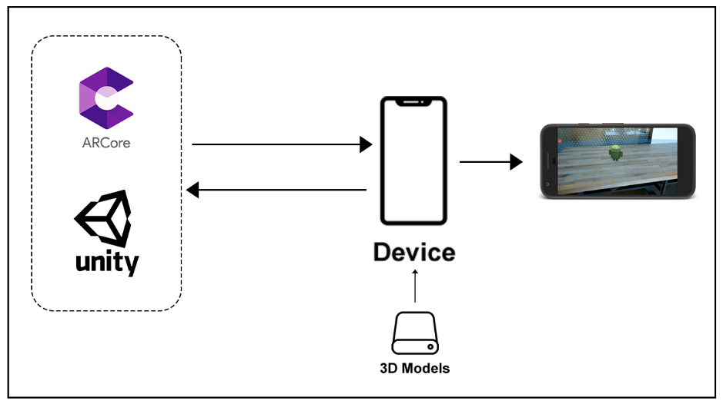This section aims to provide users with a quick comprehension of how the system functions, aiding them in understanding the system better.

*Figure 1. Augmented Reality Workflow Diagram*

The figure above shows the basic workflow/process of the AR App. The process of projecting a 3D model into the augmented world through Augmented Reality involves the device communicating with both the Unity3D Engine and ARCore SDK. To achieve this, ARCore utilizes the SLAM algorithm to determine the device's current proportion, location, and orientation in the real world. Initially, the 3D model is stored within the application itself, and then it proceeds to the Unity3D engine, where the texture and shape of the model are applied. ARCore then gathers the device's position and orientation information to determine the 3D model's position in the real world. Finally, ARCore places the 3D model in the augmented world while continuously collecting device position and orientation data.

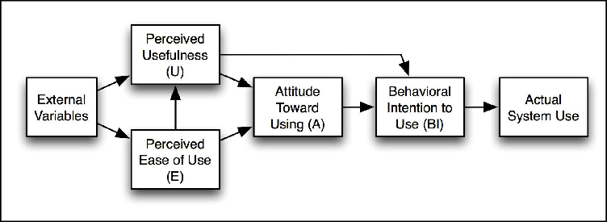 *Figure 2. Technology Acceptance Model*

The Technology Acceptance Model (TAM), which was first presented by Fred Davis in 1986, was described by López et al. (2019). The model indicates that the acceptance of technology for the learning process is influenced by the beliefs and behaviors of its users, as well as the perceived value and ease of usage. Furthermore, TAM is the most widely adopted model and has been used to explain technology acceptance in numerous studies. Additionally, TAM has gained widespread acclaim for its ability to predict students' acceptance of technology and explain their perceptions of embracing technology.

Moreover, by using TAM, the researcher can explore the factors that influence students' attitudes and intentions towards using the Augmented Reality application, such as perceived usefulness, ease of use, and social influence. Additionally, the Technology Acceptance Model (TAM) offers a theoretical framework to identify the factors that impact the adoption of technology, such as Augmented Reality (AR), and how it can affect the learning outcomes of children (Purwaamijaya, 2019).

This will help to ensure that the application meets the needs of the users and is effective in enhancing science learning among Grade 5 students at St. Peter's College.

The TAM theory consists of four main factors: perceived ease of use (PEU), perceived usefulness (PU), attitudes toward technology use (ATU), and behavioral intention (BI). In addition, the variability of these four main components can be influenced by factors such as gender, age, experience, and voluntariness of the study participants. Furthermore, the model postulates that the acceptance of a new technology or system is predicated on the levels of Perceived Ease of Use (PEU) and Perceived Usefulness (PU), which in turn influence Behavioral Intention (BI) after being mediated by Attitude Toward Usage (ATU) (Davis, 1989).

*Perceived Usefulness (PU): refers to an individual's perception or belief about how using a specific technology can enhance their performance (Davis, 1989).*

*Perceived Ease of Use (PEU): refers to the extent to which an individual believes that utilizing a specific technology will be effortless (Davis, 1989).*

*Behavioral Intention (BI): BI is a measure that reflects the level of willingness of an individual to exert the necessary effort to perform a desired behavior, such as using computers (Lee et al., 2012).*

**Research Objectives**

In this section, the researcher identifies both broad and particular aims.

**General Objectives**

The primary goal of the study is to develop a Mobile Augmented Reality Application for Grade 5 Students of St. Peter’s College in Iligan City. This study used the Technology Acceptance Model to evaluate the Mobile Augmented Reality Application and Specifically, this study aims to:

1. Develop a Mobile Augmented Reality for Science Learning, which includes the following functionalities:
   1. Animated 3D models
   2. Informative 3D models
   3. 3D models adherent to students’ book
   4. Note keeper
2. Assess the effectiveness and acceptance of the Mobile Augmented Reality Application by students through the utilization of the Technology Acceptance Model.

**Scope and Limitation**

The main emphasis of the research is to develop a Mobile Augmented Reality Application for learning science that will help students to be more engaging on science learning and help them to easily understand science concepts, which will be conducted within St. Peter’s College, Sabayle St. Iligan City, specifically for Grade 5 Students.

The researcher's focus is solely on creating a Mobile Augmented Reality Application, which may include the functionalities mentioned in the previous section of the study. Additionally, the researcher utilized ARCore to implement Augmented Reality and enable the superimposition of 3D objects or models onto the augmented world.

The algorithm, SLAM, which is already included inside ARCore SDK and Unity3D a game engine, will be the in charge to overlay the 3D models and determines the device position and orientation.

Other platforms, devices and documentation tools are not included in the study. Moreover, some functionalities that are not included in the study are:

* Ability to create lessons
* Ability to create quiz
* Creating an account

**Significance of the Study**

This research will be valuable for individuals who intend to utilize the system in the future, including students**.**

* Students will benefit from this application by using it for learning and understanding science easily.
* Future researchers can benefit from the system developed in this study as it provides not only assistance to students but also serves as a valuable source of ideas and inspiration for those interested in pursuing similar research.

**Definition of Terms**

The operational definitions of the following terms were provided to facilitate better comprehension of the study:

Augmented world refers to a virtual environment created through augmented reality

(AR) technology.

AR (Augmented Reality) is a technology that overlays digital information onto the

augmented world.

3D models are digital representations of three-dimensional objects or environments

that can be used in various applications such as games, simulations, and

visualizations.

ARCore is a software development kit (SDK) developed by Google that enables the

creation of augmented reality (AR) applications for mobile devices. ARCore will be

used to overlay the 3D images in augmented world.

Android is a mobile operating system developed by Google.

Devices refer to electronic tools or machines designed to perform specific tasks or

functions. Android Device will be used for AR.

Device position and orientation: refers to the spatial location and orientation of a

device. It will be used for AR to project the model.

Game engines are software platforms designed to help developers create video games.

Lesson instructional sessions that teacher create and which will student can view or

read.

SLAM (Simultaneous Localization and Mapping) is a technology used in robotics

and computer vision for mapping and navigating an environment.

SDK stands for software development kit and is a collection of software development

tools that allow developers to create applications for specific platforms.

SQLite is a relational database management system that is designed to be embedded  
 into software applications.

Students, as the system users.

TAM (Technology Acceptance Model) - model for understanding how users perceive

and adopt new technology.

Unity3D is a game engine used for developing 2D and 3D video games.

**Chapter 2**

**Review of Related Literature**

This chapter presents an in-depth analysis of the problem addressed in this study, along with its proposed solution.

**Augmented Reality**

Over the past few decades, the integration of technology in education has brought about a significant change in the way knowledge is imparted to students. With the use of technology combined with effective teaching methodologies, there has been a surge in the development of innovative techniques that aim to enhance the quality of the teaching and learning experience and one such example of technology is Augmented Reality (AR)

Augmented Reality (AR) is a technology that overlays digital content onto the physical world, creating an immersive and interactive user experience. Furthermore, the word "augmented" in "augmented reality" means to enhance or improve something by adding elements to it. In the context of technology, it refers to the enhancement of the physical world through digital elements, such as graphics, sounds, and other sensory inputs, which are overlayed onto real-world objects or environments in real time. This creates an immersive experience that blends the digital and physical worlds together.

Furthermore, according to Cabero-Almenara et al. (2019), Augmented Reality (AR) is a developing technology that is becoming more prominent in the field of education. When combined with mobile technology, AR is considered to be one of the most effective tools for facilitating meaningful and widespread learning. Additionally, Augmented Reality (AR) has the potential to revolutionize the way educational materials are presented across all levels of learning, from public outreach events to advanced teaching at the undergraduate and postgraduate levels. The appeal of AR as a teaching aid lies in its capacity to provide a blended learning experience that combines the virtual and real-world environments or materials in the classroom (Barrow et al., 2019) and has the potential to enhance student learning motivation and lead to improved academic achievement (Khan et al., 2019). Besides, it offers a superior user experience as a result of its ability to showcase 3D virtual information and facilitate interaction (Majeed and Ali, 2020).

Similarly, Sahin and Yilmaz (2020) also noted that Augmented Reality (AR) is significant in presenting abstract ideas in a tangible form that matches students' comprehension level, and it allows for the observation of events and objects that would be impossible to experience in real life.

**Technology Acceptance Model (TAM) Theory**

The Technology Acceptance Model (TAM), a theory of information systems, simulates how consumers adopt and use technology. The point at which humans employ technology is during real system use. People utilize technology for a variety of reasons, one of which is behavioral purpose. TAM and its expansions have found usage in a variety of applications across many fields, settings, and places, providing a crucial theoretical tool for forecasting user behavior.

With perceived ease of use and perceived utility as the two main criteria affecting a person's desire to utilize new technology, TAM has been one of the most prominent models of technology acceptance. It has been used in many different sectors, including business, healthcare, and education.

The Technology adoption methodology (TAM) assessment methodology, which was first presented by Fred Davis in 1986, is described by López et al. (2019) and shows that adoption of a technology for the learning process is impacted by beliefs. The behaviors of its users, as well as the perceived value and simplicity of usage.

According to Jang et al. (2021), Several models have been proposed to explain technology acceptance, including the Theory of Reasoned Action (TRA), Technology Acceptance Model (TAM), and Unified Theory of Acceptance and Use of Technology (UTAUT). Among these models, TAM is the most widely adopted and has been used to explain technology acceptance in numerous studies. The TAM has gained widespread acclaim for its ability to anticipate teachers’ adoption of technology and to explain their perceptions of teachers’ embrace of technology.

**Simultaneous Localization and Mapping (SLAM) Algorithm**

SLAM, or simultaneous localization and mapping, is a method used in computer vision and robotics to create or update a map of an uncharted area while simultaneously keeping track of an agent's location inside it. We may employ SLAM techniques in the augmented reality experience to add virtual objects based on the user's observation point (location) and environment structure. Similarly, Singandhupe and La (2019) explained that Simultaneous Localization and Mapping (SLAM) is an algorithm that enables a robot or sensor system to perceive its environment using sensors and estimate its own position in the environment at the same time.

As an example, Liu et al. (2019) cited that for registering both actual and virtual environments in AR, tracking registration technology is essential. The tracking registration method must be able to reliably and swiftly follow a moving subject robustly and in real time, which is more difficult given the irregular camera motions in mobile AR. Additionally, Tang and Cao (2020) also noted that AR technology requires attention to three primary aspects: three-dimensional registration, authenticity in virtual-reality fusion, and effective human-computer interaction. Of these aspects, three-dimensional registration is particularly crucial as it plays a central role in achieving convincing virtual fusion effects. Therefore, one of the primary techniques for 3D registration is Simultaneous Localization and Mapping (SLAM), which is capable of determining the device's position in real-time even in unfamiliar environments (Li et al., 2019).

In addition, ARCore, an augmented reality (AR) platform developed by Google that enables developers to create AR experiences for Android devices. It uses the device's camera, sensors, and motion processors to understand the environment and place virtual objects on top of the real world. Overall, ARCore's use of SLAM technology allows it to create accurate and stable AR experience.

To sum up, Augmented Reality (AR) has emerged as an innovative technology that provides students and teachers with a unique learning experience in science education. The benefits of AR for education are numerous, including enhanced engagement, improved comprehension, and increased motivation.

**Chapter 3**

**Technical Background**

This section involves researching the technical requirements for developing and implementing the system, as well as seeking recommendations from acquaintances and advisers to determine the most suitable design. The following list presents all the gathered ideas.

**Overview of the Current Technology**

The current state of AR technology is that it is still in its early stages of development. However, it has been making significant progress in recent years.AR technology has been used in various fields such as education, healthcare, gaming, and retail (Alsop, 2022). It has also been used for training purposes in industries such as aviation and military (Makarov, 2022).

According to Sidharth (2021) implementation of AR and VR in the education sector is one of the augmented reality technology trends to try in 2023. Similarly, Augmented Reality (AR) has been widely researched and utilized as a technology that supports learning and teaching processes. The research community has shown significant interest in AR due to its ability to provide distinct learning experiences that cannot be achieved through alternative technologies or approaches (Avila-Garzon et al., 2021).

Additionally, usage of AR in the industrial environment will only grow, and that’s a statement backed by hard facts. 2023 will be another year of companies transforming digitally to match the demand of Industry 4.0 – and augmented reality is one of their most powerful allies (Kessler, 2022).

**Hardware**

The following computer hardware requirements are necessary to design and execute the suggested system.

*Mobile Device:*

* Android 8.1 Oreo is the most palatable mainstream Android version yet. It is visually consistent, simplified, feature-rich and polished.
* Qualcomm Snapdragon 636 refers to an Octa-Core Processor that comprises eight Kryo 260 cores, which can operate at a maximum clock frequency of 1.8 GHz. The Kryo 260 Cores outperform the ARM Cortex-A53 Cores of SD 630 by 40% in terms of performance. Moreover, MediaTek Helio G35 is a chip that employs an octa-core processor built on 12nm architecture. However, it does not feature the faster A55 or A7x cores, but only Cortex-A53 cores. The processor runs at a speed of 2.3GHz and can support up to 6GB of RAM, which is of the LPDDR4x type with a frequency of 1,600MHz. The chip can also accommodate cheaper LPDDR3 memory with a maximum capacity of 4GB.
* A minimum of 4GB RAM is required for web browsing, social media, video streaming, and some popular mobile games, although the amount of RAM required varies depending on the apps you use (Phillips, 2022). Furthermore, gigabyte (GB) is a measure of digital information equivalent to one billion bytes. It refers to the size of a computer file or software that contains a billion bytes.
* With 64GB, you'll have enough if you use your phone for WhatsApp and calls. In addition, you have space for some social media apps and light games.
* The graphics card should be Adreno 509 for Snapdragon Chipsets and GE8320 for MediaTek Chipset or later that can support Augmented Reality (AR). A chipset refers to a collection of integrated circuits or motherboard chips that are interdependent and responsible for regulating the movement of data and instructions between the CPU or microprocessor and external devices. A graphics card, also known as a display adapter or video card, is a component found in most computing devices that is responsible for rendering graphical data with high clarity, definition, color, and overall visual quality.
* The Camera must at least clear and not blurry in order for ARCore to work correctly.

Provided that the mobile device satisfies the following requirements - Android 8.1 or a later version, sufficient storage space, a high-resolution camera, and support for Augmented Reality, the application can display Augmentation and projections of models without any issues. However, the performance of the system or application depends on how well it is developed.

**Software**

In terms of software, these are the things that are recommender according to online searches gathered by the researcher.

* C# (pronounced “See Sharp”) is a modern, object-oriented, and type-safe programming language created by Microsoft. C# enables developers to build many types of applications such as Windows client applications, Web services, database applications, and more.
* Unity3D is a cross-platform game engine used for developing 2D and 3D games, simulations, and interactive experiences. It will be used to develop the mobile augmented reality application.
* ARCore is a software development kit (SDK) developed by Google that enables the creation of augmented reality (AR) experiences on Android devices. It will be use to project 3D Objects on real world. ARCore uses Simultaneous Localization and Mapping (SLAM) Algorithm to map the environment and place digital objects in the real world.
* SQLite is a software library that provides a relational database management system. It is designed to be a self-contained, serverless, transactional SQL database engine. SQLite is one of the most widely deployed databases in the world, as it is integrated into many operating systems, browsers, mobile devices, and other software products.

**Peopleware**

Grade 5 Students of St. Peter’s College Iligan City are the users who are involved in the implementation of the system and can use it as a means to learn and comprehend science concepts more effectively. The students may use the AR app with their books to understand science concept hence gaining more motivation and knowledge in learning science.

**Chapter 4**

**Design and Methodology**

The methods and procedures employed by the researcher were utilized to facilitate the development and construction of the suggested system.

The researcher utilized the Agile Methodology Model for the development of the system. The Agile methodology is a framework for software development that emphasizes collaboration, an iterative approach, and adaptability throughout the software development process (Rachmawati et al., 2021).

Moreover, according to Kaliparambil (2022), the mobile app development process using Agile methodology is highly adaptable, enabling the researcher to customize the timeline based on specific requirements and preferences. This approach prioritizes incremental improvements and offers flexibility in organizing software and mobile app development efforts.

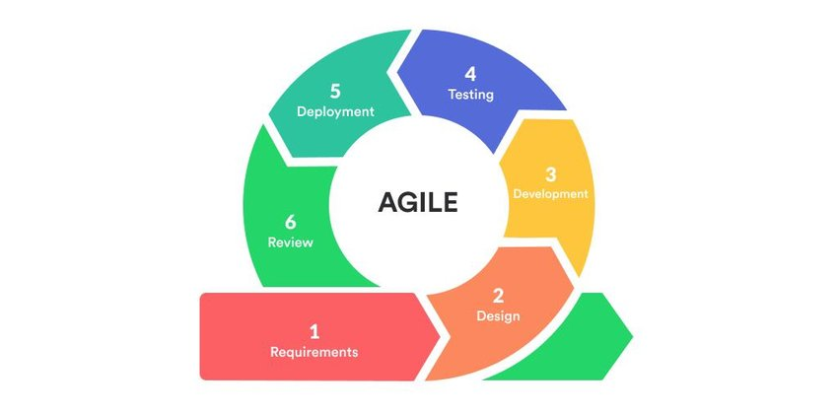 *Figure 3. Agile Methodology*

The aim of this study is to utilize the Agile methodology to create a Mobile Augmented Reality for Science Learning, which will serve as a learning and assessment tool for St. Peters College-Iligan Grade 5 Students and the general public. This will be achieved through the implementation of the six phases of the Agile methodology.

1. ***Requirements Phase -*** In this phase, the scope of the project determines, prioritize important tasks, and establish key requirements with the client. The requirements will be kept minimal and can be added to later on.
2. ***Design Phase -*** In this phase, an analysis will be performed to determine the appropriate business logic, database models, and technical requirements (languages, data layers, services, etc.) needed to meet the requirements from the previous phase.
3. ***Development and Coding Phase -*** With the planning and analysis out of the way, the actual implementation and coding process can begin. All planning, specification, and design docs up to this point will be coded and implemented into this initial iteration of the project.
4. ***Integration and Testing Phase -*** Once the current build iteration has been coded and implemented, the next step is to go through a series of testing procedures to identify and locate any potential bugs or issues that have cropped up.

These were the procedures observed:

1. Testing the proposed Mobile Augmented Reality Application against the major system.

The previous section mentioned certain functionalities or processes, namely:

System Testing - This test encompasses all the processing scenarios that were evaluated by the system against the expected performance of different users.

Unit Testing - The researcher conducted unit testing to identify and eliminate errors that could cause the program to terminate unexpectedly

1. ***Implementation and Deployment Phase -*** After successful testing, the system is ready to be implemented and deployed.
2. ***Review Phase -*** Once the system is deployed, it will undergo review to determine any improvements or adjustments that need to be made for the next iteration.

**Proposed Framework**

The proposed framework shows the connection between the system and users, where users can interact with the system by accessing it and using the AR feature by pointing the camera to an image. Additionally, users can create notes within the app, which can be overlaid on the AR. These notes will then be stored in the app's database.

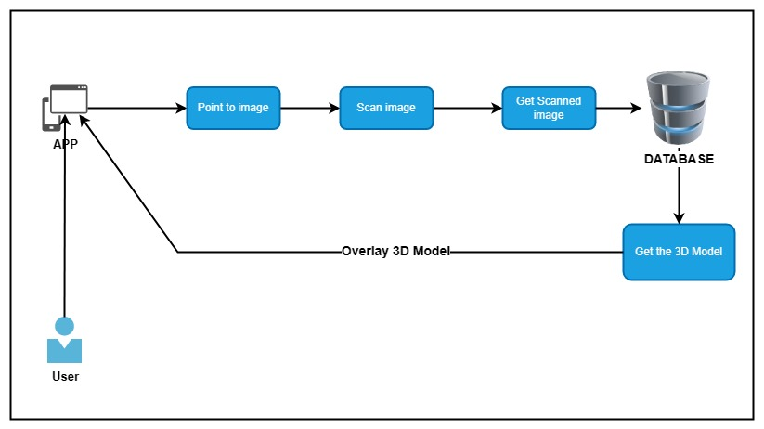

*Figure 4. Sci-AR – Getting 3D Model from database*

These are the actions that a user can perform:

1. Use Augmented Reality – the ability of using augmented reality
2. Create Notes – the ability to create notes
3. Edit Notes – the ability to edit existing saved notes
4. Delete Notes – the ability to delete existing saved notes

**Tools and Techniques used in the study**

**Tools and Techniques**

The methods and instruments employed to complete the study consist of utilizing Use Case to demonstrate the capabilities available to the user, and utilizing Activity Diagram to illustrate the interaction between the user and the system.

**Use Case Diagram**

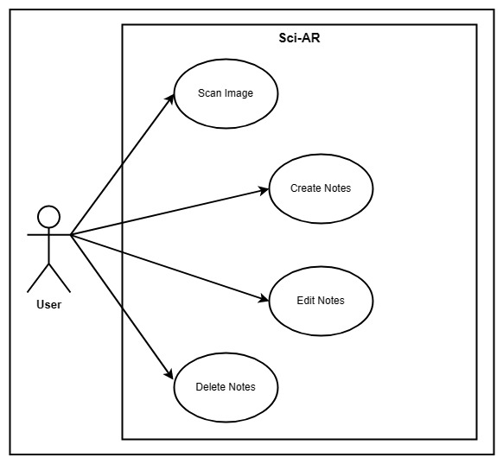A use case diagram is a form of visual modeling that depicts the main components and how they interact in a system. They can be used to identify the major parts of a system and how they interact, which is helpful in ensuring that all necessary steps are taken in order to complete a task. They are also helpful for discovering potential areas for improvement (Mahr, n.d).

*Figure 5. Use Case Diagram*

**Use Case Diagram Description Table**

|  |  |
| --- | --- |
| **Use Case** | **Description** |
| Scan Image | When user scan an image |
| Create notes | User create notes |
| Edit notes | User edit existing notes |
| Delete notes | User delete existing notes |

*Table 1. Use Case Diagram Description Table*

As shown in the Figure 5, a use case outlines the manner in which an individual utilizing the process or system will achieve an objective.

The user can use the augmented reality with the adherent science book. Additionally, the user can also take a note to save some information and can also later be edit or deleted.

**Sequence Diagram**

Sequence diagram is used to depict the interactions between objects in a system in a sequential order. They are primarily used by developers and business analysts to comprehend project requirements. These diagrams demonstrate the interactions between various parts of the system and the order in which they occur. They display the elements as they interact over time, where the objects are placed on the horizontal axis and time on the vertical axis. The horizontal axis represents the objects interacting with each other, while the vertical axis represents the progress of time (Ijaz, n.d).

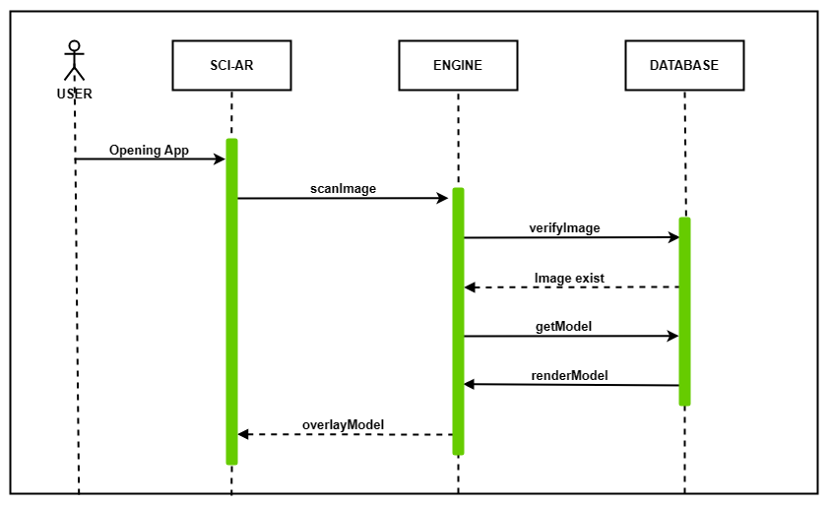

*Figure 6. Sequence Diagram*

Figure 6 illustrates the application’s sequence diagram. The user will open the app and instantly be brought to a camera-like UI. Afterwards, the user can use the app to point at the images in the book, and the app will scan the image with the scanImage function and check its existence in the database using the verifyImage function. After verifying its existence, the app will retrieve the corresponding 3D model using getModel function and overlay it into the real world.

**Activity Diagram**

Activity diagram is a modeling tool that is utilized to represent the sequential workflow of a significant activity. It concentrates on the sequences of actions and their corresponding conditions for initiation. The state of an activity is linked to the execution of each step of the workflow.

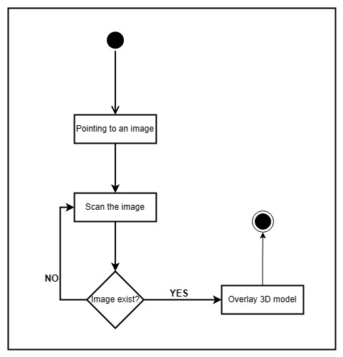

*Figure 7. Activity Diagram*

Figure 7 illustrates a simplified diagram of how the system functions. Initially, the user will be directed to a camera-like UI, which they can utilize to point to an image in the book. The application will then automatically scan the image and check it against the saved images for AR in the database, which also has a corresponding 3D model. Once the model is confirmed, the app will retrieve the corresponding 3D model and overlay it onto the real world.

**Data Flow Diagram**

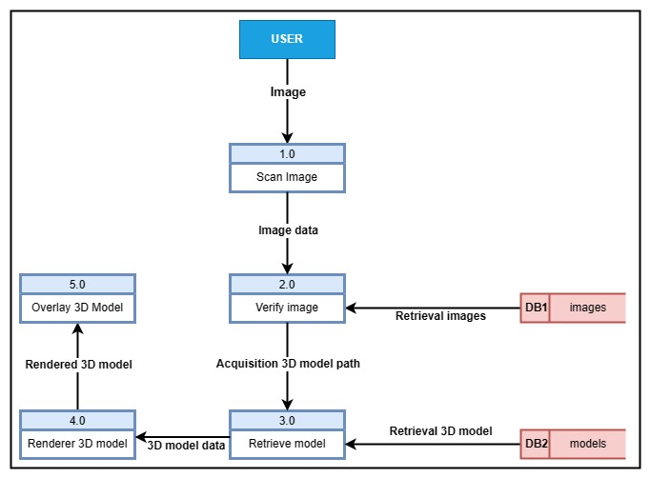A data flow diagram (DFD) illustrates how data is processed by a system in terms of inputs and outputs. As its name indicates its focus is on the flow of information, where data comes from, where it goes and how it gets stored.

*Figure 9. Data flow Diagram*

Figure 9 shows the flow of data of the application. Upon pointing on an image on the book, the application immediately scans the image. After scanning the image, the next process is verifying the image by checking it on the database if it exists. After that, if the image exists, the process then retrieves the corresponding 3D model for the image and then process the 3D model for the rendering. After rendering, the 3D model will be then ready to be overlay into the rea world.

**Context Diagram**

The Context Diagram shows the system under consideration as a single high-level process and then shows the relationship that the system has with other external entities (systems, organizational groups, external data stores, etc.).

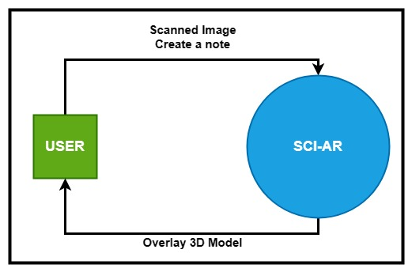

*Figure 10. Context Diagram*